1) Name of Seminar: Seminar on innovation and Start up
2) Date of seminar: 20th July 2023
3) Time: 01:00 – 03:00 PM
4) Name of Expert: Dr. Kuntesh K Jani (Internal Faculty)

5) Name of Coordinator: Dr. Kuntesh K Jani
6) Designation of Coordinator: Assistant Professor
7) Email ID: kuntesh.jani@ldce.ac.in
8) Mobile No: 99980036360
9) Number of Participants: 45
10) Registration Link: -
11) Expert contact No. : - 9998003630
12) Expert email ID: - kuntesh.jani@ldce.ac.in
13) Expert’s Designation and college name: - Assistant Professor – LDCE.
14) Photo graphs of Seminar:
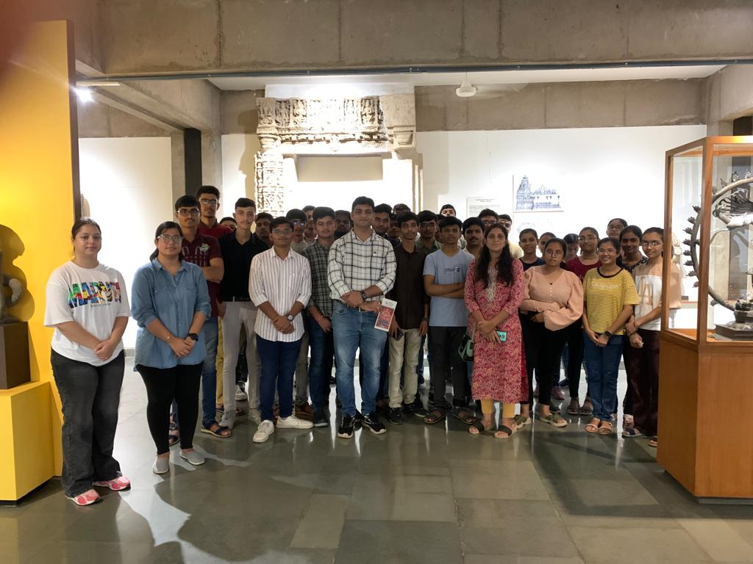 | 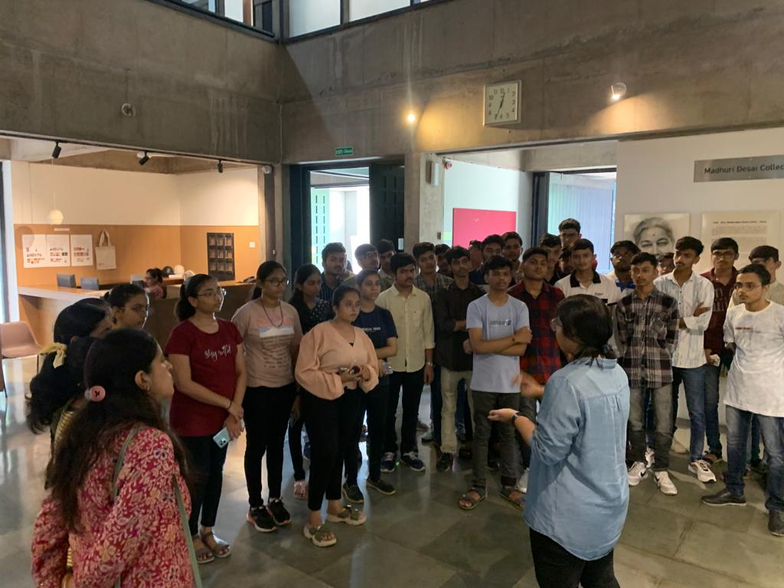

15) Venue: 3001 – Annexie Building

